IBANDA CELEBRATES WORLD AIDS DAY
By Sylas Byaruhanga
On 5th December 2018, Ibanda District Local Government celebrated the world AIDs day.
Celebrations were held at the Bisheshe Divison headquarters in Ibanda municipality. The theme of the day was “know your HIV status and leave a good life”
During the function, the DHO Dr. Bamwine Julius gave the HIVAIDS status noting that the prevalence rate slightly reduced from 6% last year (2017) to 5% this year (2018).
Bamwiine also highlighted the major causes of HIVAIDS spread as persistent alcoholism, increase of sex workers in Ibanda town especially on Mpiira Street, poverty, domestic violence which makes men vacate their homes to seek for rest outside their homes among others.
Several activities which included testing for HIVAIDS, hepatitis B, cervical cancer among others took place at the function
Several presentations about the spread of HIVAIDS scourge were made by school children and posttest clubs.
The RDC Mr. Akatuhebwa Eliasto cautioned people against family neglect, poverty and negligence as the major causes of the HIVAIDS spreads.
He encouraged abstinence among the young people and trustworthiness among the married couples.

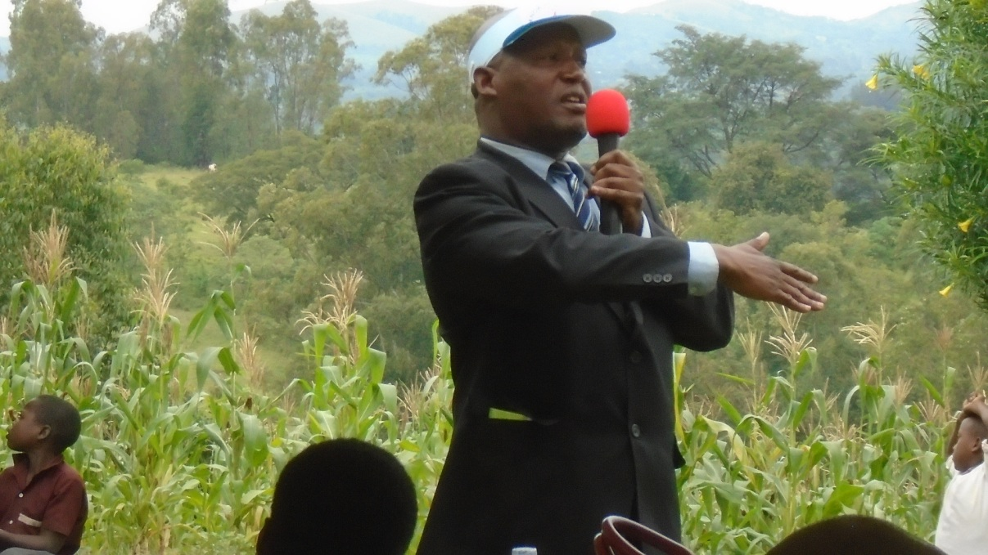
Mr.Mukiza Dominic the District Probation Officer explaining the relationship between Domestic violence and the spread of HIVAIDS scourge during the function .Photo by Sylas Byaruhanga
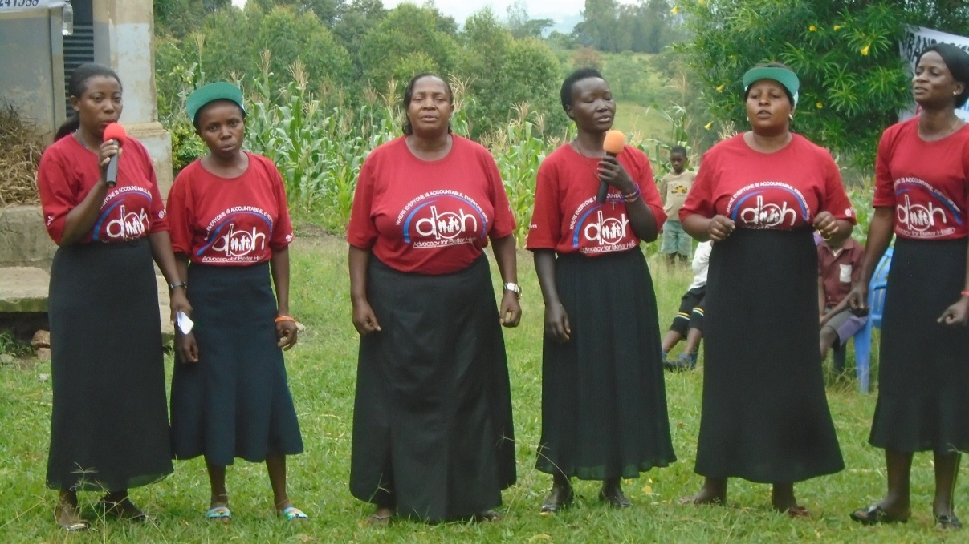
Members of posttest club of Ibanda performing during the function. Photo by Sylas Byaruhanga

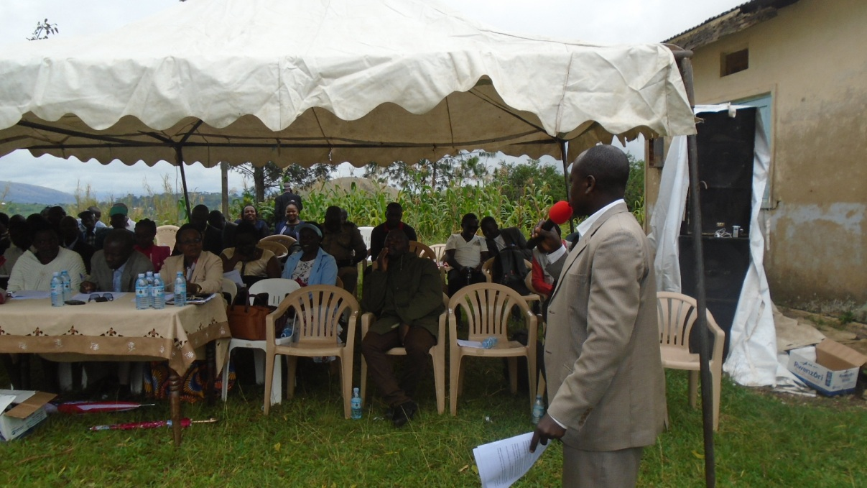
Dr. Bamwine Julius giving the state of the district HIVAIDS status in Ibanda district.

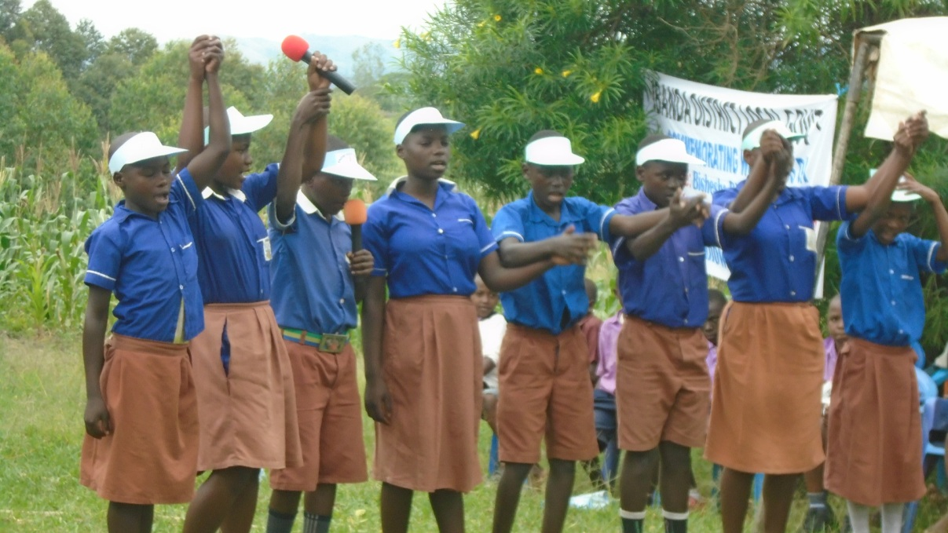
Pupils of Kashozi Preparatory School giving a poem about the spread of HIVAIDS Scourge. Photo by Sylas Byaruhanga.

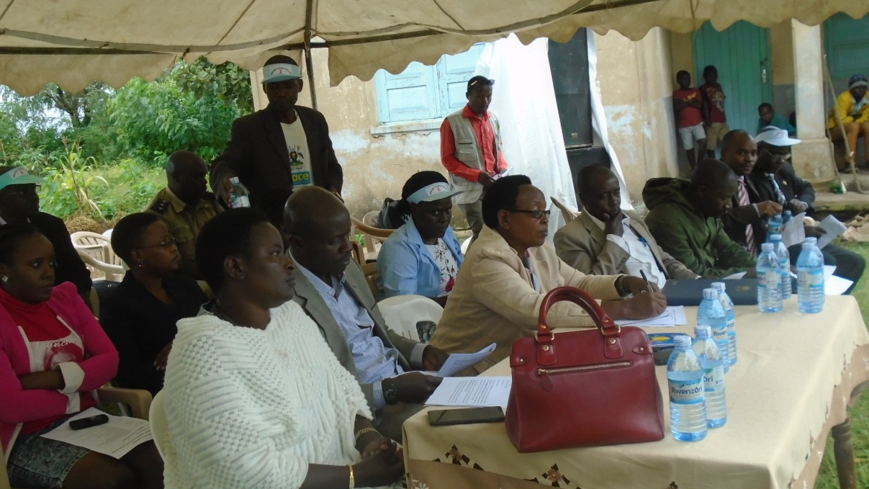
Ibanda District leaders also attended the function. Photo by Sylas Byaruhanga

